The Magic Universe

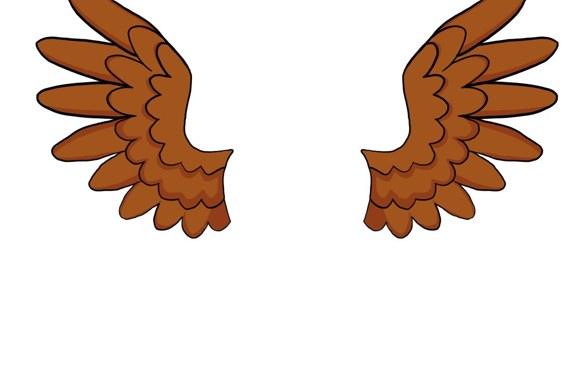

Name: ___________________

Year: ____________________

**Write a letter to any mythical creature, explaining why you admire them and what creature you would be.**

In an alternate universe, there is an Outspoken High where everybody is the same but different, it is not a normal student life in this universe. , witches, wizards, werewolves, mummies, and many other creatures roam the school halls. With potions classes, dragon-flying lessons, and many other fun school activities for the mix of students.

“Hey Iris! You  amazing today!”, Asuka exclaims while growling, she is a werewolf. “Thank you, Asuka. It is difficult to get ready in the mornings when you cannot see your reflection,” Iris says in a very monotonous tone, Iris is a . It is a beautiful school day with the most amazing weather, a dark grey,  day with a gush of wind that rustled every  on the  around the schoolyard.

A dragon swoops down and sits politely in front of Aiden, he is a dragon trainer, and he is also part dragon. “Hey girls! How are you doing today?” Aiden asks politely, coughing  into his arm. Oscar swoops down to the ground with his giant eagle 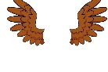, trying not to scratch anyone with his massive lion  and talons, Oscar is part Griffin. “Hey! What is up, non-people? Haha! See what I did there?” Oscar is  at his own joke. “That was quite lame!” Asuka says, smirking at Oscar.

The students have a full day of classes ahead, including dragon-flying where Aiden will help teachers with the dragon training. Tiny, little pixies flutter around the schoolyard and through the beautiful that are growing in the garden and through the massive, deep green .

It is almost  time, and everyone is  to sit on the garden lawns and share their experiences from the day so far. The next activity is to go up to the haunted  on the hill and tour around, finding out the mysteries that remain in the broken brick walls. What a fun evening it is going to be.